**TA/PLA Web Application**

**Requirements Analysis &**

**Design Document**

Software Engineering Group H:

Zac Crane

Xuan (Sharon) Liu

Devin Petersohn  
Madelyn Petersohn

Daniel Raymon

Zening (Paul) Zhang

**Table of Contents**

Change Log 3

Requirements Analysis 4

Users 4

Activities 4

Functional Requirements 4

Nonfunctional Requirements 5

System Requirements 5

System Design 6

Introduction 6

Current System 6

Proposed System 7

Introduction 7

System Overview 8

Glossary 10

Diagrams 11

Use Case 11

Architecture 12

System Design 13

Activity Diagrams 17

Sequence Diagrams 20

ERD 22

# Glossary

**Activity Diagram:** Visual representation of the logical workflow of actions for a functionality of the system.

**Admin:** A user who has permission to log in, create Admins, perform system maintenance, block accounts, and manage the system code.

**Applicant:** A user (including undergraduate, graduate and International students) who has permission to log in, submit an application, view application/notification status and accept or reject an offer.

**ERD (Entity Relationship Diagram):** A visual representation of the relationship between database entries. Demonstrates how the database will be set up.

**Faculty:** A user (including faculty/staff/instructors) who has permission to log in, review applicants, search for and request applicants for a course, and comment/rank TAs/PLAs.

**File Server:** A device that will control access to separately stored files. In this case, that separately store file will be the applicants’ resume, saved as a PDF.

**PLA:** Peer Learning Assistant (undergraduate student)

**RDBMS:** A database management system that will store all data/information about each user and course.

**Sequence Diagram:** Interaction diagram that visualizes how processes operate with one another and the order in which they occur.

**System Admin:** A user who has permission to log in, create courses, assign TAs/PLAs to a course, search for an applicant, and enter rankings for TAs/PLAs.

**TA:** Teaching Assistant (graduate student)

**Use Case Diagram:** A visual representation of the functionalities each user of the system will perform.

# Change Log

|  |  |  |  |
| --- | --- | --- | --- |
| **Date** | **Version** | **Description** | **Authors** |
| 3/19/2015 | 0.1 | First Draft | Zac Crane  Daniel Raymon  Zening (Paul) Zhang  Xuan (Sharon) Liu  Devin Petersohn Madelyn Petersohn |

# Requirements Analysis

## Users

* Administrator
  + Admin
  + Sys Admin
* Faculty/Instructor
* Applicant

## Activities

* Admin
  + Log In
  + Perform maintenance (including setting time windows)
  + Create Admin
  + Block account
  + Search for specific applicant
* System Admin
  + Log In
  + Create courses
  + Assign TAs/PLAs to courses
  + Enter rankings for TAs/PLAs
  + Search for specific applicant
* Applicant
  + Log In
  + Submit application form
  + View application status
  + View notification
  + Accept/reject offer
* Faculty/Instructors
  + Log In
  + Review Applications
  + Search for specific Applicant
  + Comment on students
  + Request TAs/PLAs for courses

## Functional Requirements

* Allow all users to log in with correct credentials
* Ability to save application if not completed right away
* Application will redirect users to SPEAK test webpage if SPEAK test question is checked “no”
* Allow Admin to create Admins/System Admins
* Allow Admin to perform maintenance, such as system updates and setting time windows
* Allow Admin to block a user account
* Allow Admin, Sys Admin, and Faculty to search for Applicants

Allow Sys Admins to create courses

* Allow Sys Admins to assign requested TAs/PLAs to a course
* Allow Sys Admin to enter rankings for TAs/PLAs
* Allow faulty to view submitted applications/resumes for all applicants
* Allow faculty to comment on applicants and rank them on a scale of 1-10
* Allow faculty to request TAs/PLAs for their course
* Allow applicants to submit application form and resume
* Ability for applicants to view application status and notification of an offer
* Allow applicants to accept/reject offer of employment

## Nonfunctional Requirements

* RDBMS
  + HTTPS
  + Salt/Hash
* Time Constraints
  + 30 minute time-out for form completion
  + 1 minute form submission, pop-up if form not submitted correctly
  + E-mail must be sent to applicants immediately after selection window closes
  + Applicant must respond with acceptance/rejection within 48 hours of notification
* Limit application submission
  + 1 per applicant
* Resume Submission
  + Only accepts PDF
  + 5 MB limit
* Electronic Signature
  + Use electronic signature to “sign” form
* Lock-in Limitation
  + Faculty is only allowed to request as many applicants as they have available positions
* Only faculty can comment on/rank/request TAs/PLAs
* Only Sys Admins can create courses and assign TAs/PLAs to courses
* Applicant can not be selected for more than one course

## 

## System Requirements

* File Server (for resume storage)
* RDBMS
* Compatible across web browsers (namely Chrome and Firefox)
* MVC Framework
* Network Connection
* OpenShiftPaaS

# System Design

# Introduction

Each semester at the University of Missouri, students have the opportunity to apply to become a teaching assistant (undergraduate) or PLA (graduate). Any student can apply for one of these positions by filling out the application form. Once these forms are submitted, faculty members have the opportunity to go through and chose from among the applicants to fill their positions.

# Current System

Currently, the TA/PLA application system is handled through the use of paper applications and Excel spreadsheets. Once the applicant has filled out the paper form, it is then turned into the Graduate Advisor. The application data is then verified and collected into a spreadsheet using Excel. After the completion of the spreadsheet, TAs/PLAs are assigned to various courses based on course enrollment and TA abilities.

As it stands, this system is inefficient and wasteful. Many hours are spent performing tasks that could be performed by a computer in a matter of seconds, such as entering applicant information and organizing/sorting applications. In addition, hundreds of sheets of paper are wasted each semester as applicants submit a new paper form. Due to the fact that the information is entered into a spreadsheet, there is no effective way to pull one applicant’s data individually without having to look through a lot of other data.

# Proposed System

## Introduction

As a solution to the current TA/PLA application system, our group proposes a completely digitized alternative web application. The goal of our application will be to allow student applicants to submit their TA/PLA application online and have the information be automatically stored in a database. Faculty will then be able to review all of these applications online through the web browser, and be able to request certain students to fill their openings. In addition, faculty will be able to leave comments about student performance and rank them based on a standard 1-10 ranking system. Once a request has been made, an administrator will be able to go into the system and assign a TA/PLA to a specific course.

We believe that this is a valuable alternative to the current system because it eliminates a lot of wasted resources and workload. By digitizing the application process, we cut the use of paper and the tedious task of manually entering the information into an Excel spreadsheet. In addition, we believe that each user will benefit from our proposed system in way that they current system doesn’t allow.

For the applicant, this proposed system is beneficial because it allows them to submit the application without having to physically turn the form in. This could possibly result in an increased number of applications being submitted each semester. In addition, we help the applicant by pre-filling some of the data fields using their personal information from the Active Directory, cutting down on the amount of work they have to do. We also give the applicant the opportunity to check the status of their application, which is something the current system does not allow.

For Faculty members, this proposed system offers many benefits over the current system. We offer the benefit of being able to comment on applicants and rank them based on past performance. This allows faulty to make informed decisions about which applicants they chose and allow them to inform other faculty members about their experiences with certain students without having to communicate in person. We also offer faculty the option of clicking a button to request a particular applicant, rather than having to compose and send an e-mail, or make a phone call.

For System Admins, the benefits of this proposed system over the current system is the elimination of manually entering applicant data into an Excel spreadsheet. All applicant data will be entered into the web application digitally and saved in the database. In addition, the Sys Admin won’t have to keep track of which faculty user requested which applicant, because the new system will keep track of that for them. It will make the whole process much more convenient and free up time to spend on more important tasks.

## System Overview

To begin using the application, a user (being an Admin, Faculty, or an Applicant) must log into the system. This login is done using their SSO (University pawprint and password). Upon submission, that information will be sent to the Active Directory for verification. If the information is correct, the user will be given permission to use the application. If the information is incorrect, an error message will be displayed and the user will have to resubmit their information. Once in the application, the options for what can be done will vary by user:

The applicant will be able to fill out the TA/PLA application form with their personal information and which class they would like to assist. In addition, they must upload their personal resume as a PDF. The current application form will be broken down into different sections so the user does not have to continuously scroll to complete the application. When an applicant is done with a certain section, they will click the “next” button, and the system will check to make sure all required boxes have been filled in. If a box is missing information, the applicant will receive and error message and be prompted to fill in the missing information. If an applicant checks that they are an international student, they will be asked if they have taken the SPEAK test. If they have not taken the SPEAK test, they will be automatically redirected to the SPEAK test webpage and their application will be saved in the system to be completed at a later time. The applicant will be able to save the application at any time before it is submitted. Once the application has been filled out completely, and a PDF resume has been attached, the applicant will submit the application using the “submit” button. The submission will be packaged and the form information will be saved to the RDBMS while the resume will be sent to the file server. If the submission is performed without any errors, the applicant will receive a message saying, “application submitted”, and the status of their application will be “submitted and awaiting review”. The applicant will be able to log in and check the status of their application throughout the course of the process. Only one application and one resume will be allowed per applicant. If an applicant is selected as a TA/PLA, the system will generate and send them an e-mail and they will be able to see this notification on the status page. They will then have the option to choose to accept or reject the offer on the web application within 48 hours of being notified.

Faculty will be able to review applications and resumes from all applicants. They can do this by searching through each applicant one by one, or using the search feature to find a particular applicant. Once they review the applicant’s information, they will have the option to click the “Select this Applicant” button, which will submit a request to the System Admin. A faculty member can only request as many applicants as they have open positions for. In addition to viewing and requesting TAs/PLAs, the application will give faculty the option to leave comments about applicants and to give them a ranking score from 1-10, 1 being unsatisfactory performance and 10 being outstanding performance. These comments and rankings will be able to be viewed by all faculty.

The Admin user will be divided into 2 separate users. The first will be Admin, which will be the person responsible for creating Admins/Sys Admins, maintenance of the system, and blocking accounts. The Admin will be responsible for fixing errors when they occur and for editing code (such as setting time windows). If an applicant or faculty user is found to be abusing the system or acting inappropriately, the Admin will be responsible for blocking them by not allowing them access to the web application. Admins will be able to search for users by name. The second type of Admin will be the System Admin, who will be responsible for creating courses, assigning TAs/PLAs to courses, and entering rankings for TAs/PLAs. They will also be able to search for users by name. When a request is made by a faculty member for a certain TA/PLA, the Sys Admin will be responsible for verifying that applicant has taken that course previously and achieved an acceptable grade. They will also be responsible for making sure that multiple faculty users do not want the same TA/PLA. When the Sys Admin assigns an applicant to a course, that applicant will receive an e-mail notifying them of the selection. The Sys Admin will be able to create courses by selecting the “create course” button and then filling out the required information about the course, such as the name, number, instructor, semester offered, etc. When all the information is completed, they will select the “submit” button, and the course will be created.

# 

# Diagrams

## Macintosh HD:Users:madelynpetersohn:Desktop:usecase.pdfUse Case

The use case diagram is outlined above. Note that the different actors of the system all have different roles they can fulfill in the system.

## Architecture

Macintosh HD:Users:madelynpetersohn:Desktop:architecture.pdf

The system architecture is shown above. A user of the system uses the UI to interact with the application. The application then interacts with the backed service over the network. From here, the backend service directs the traffic to either an active directory, the database or to the file server.

## System Design

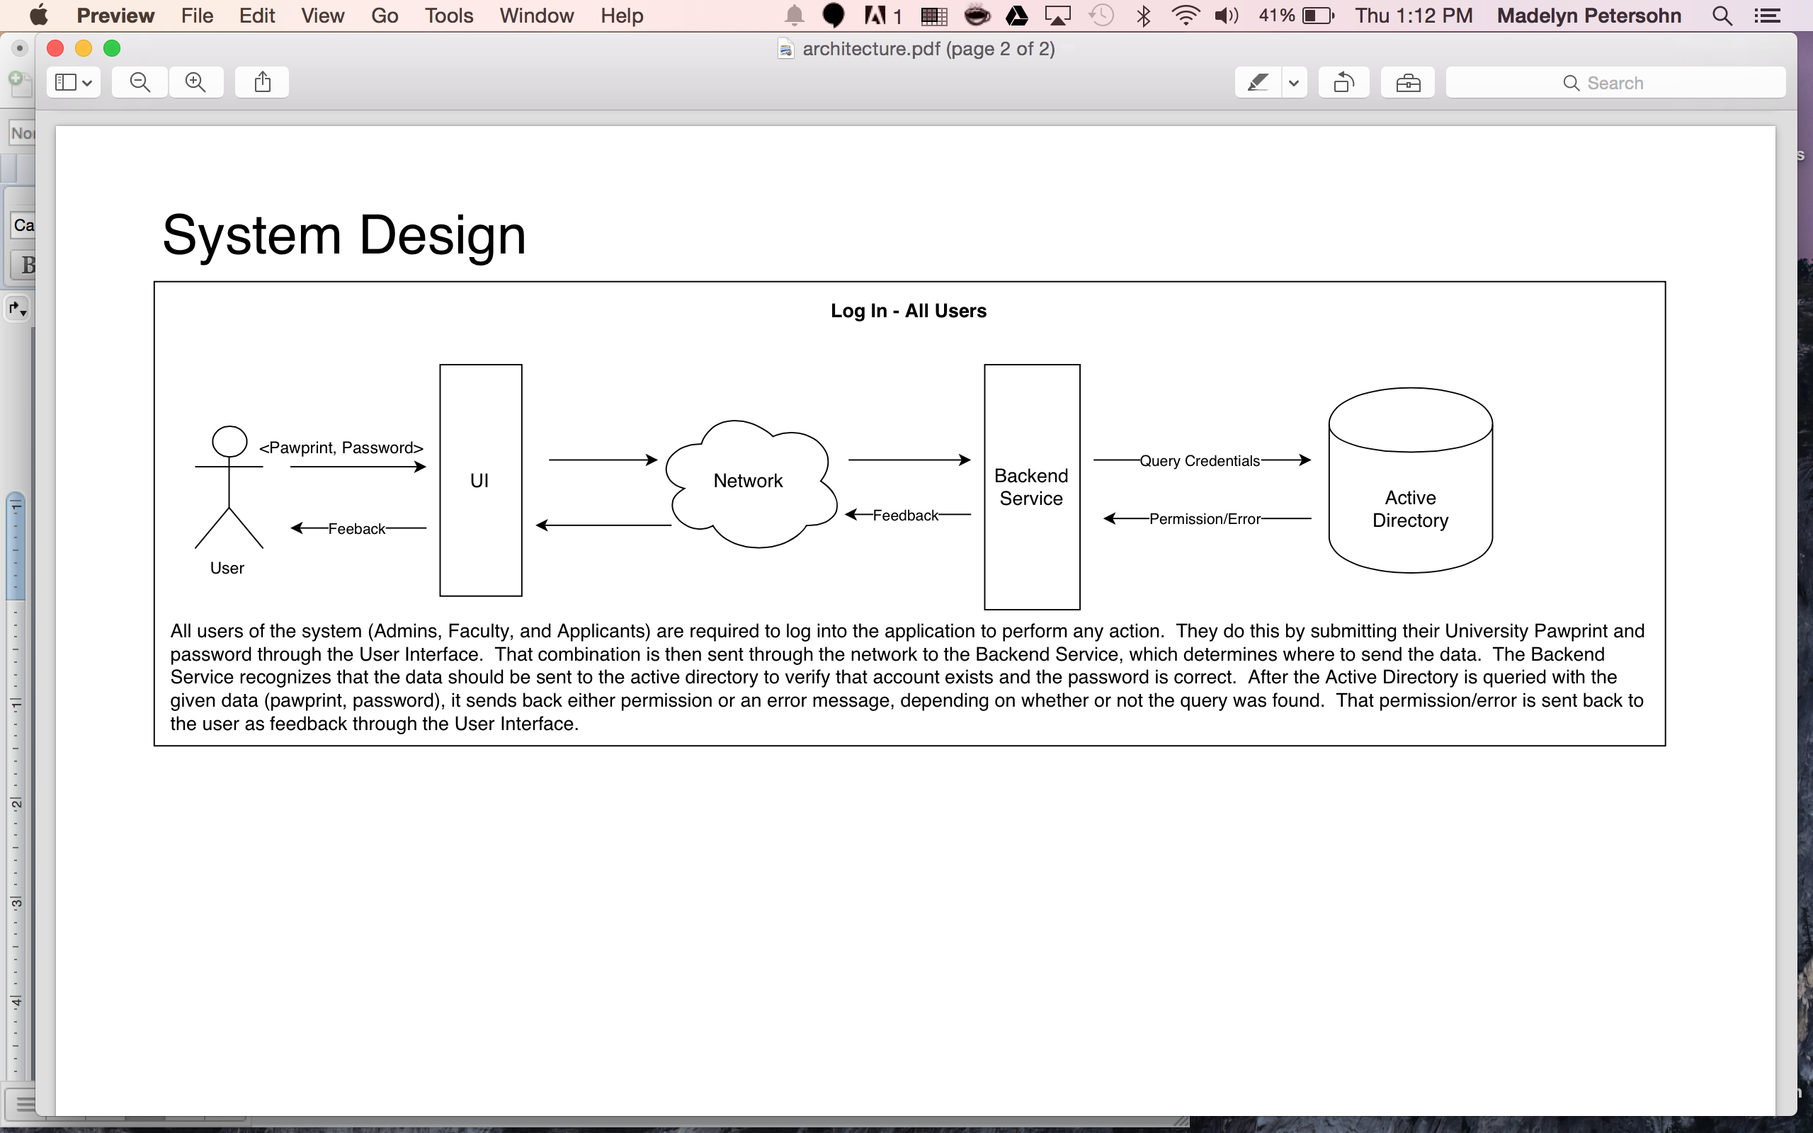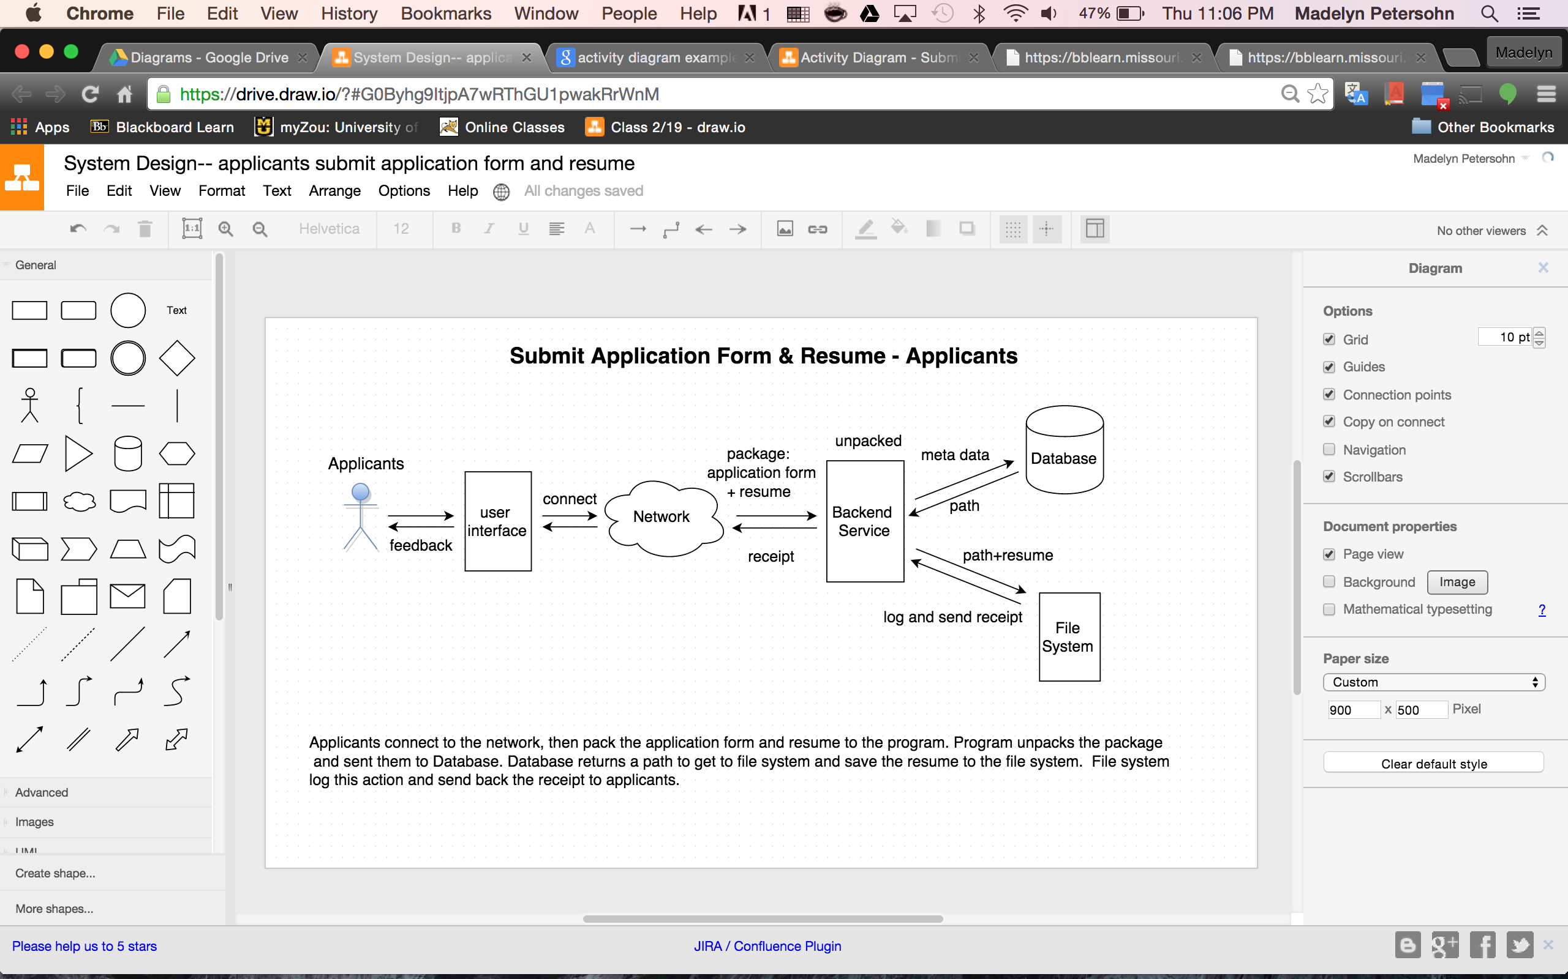

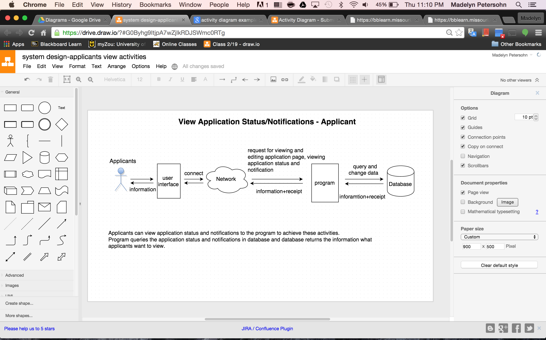

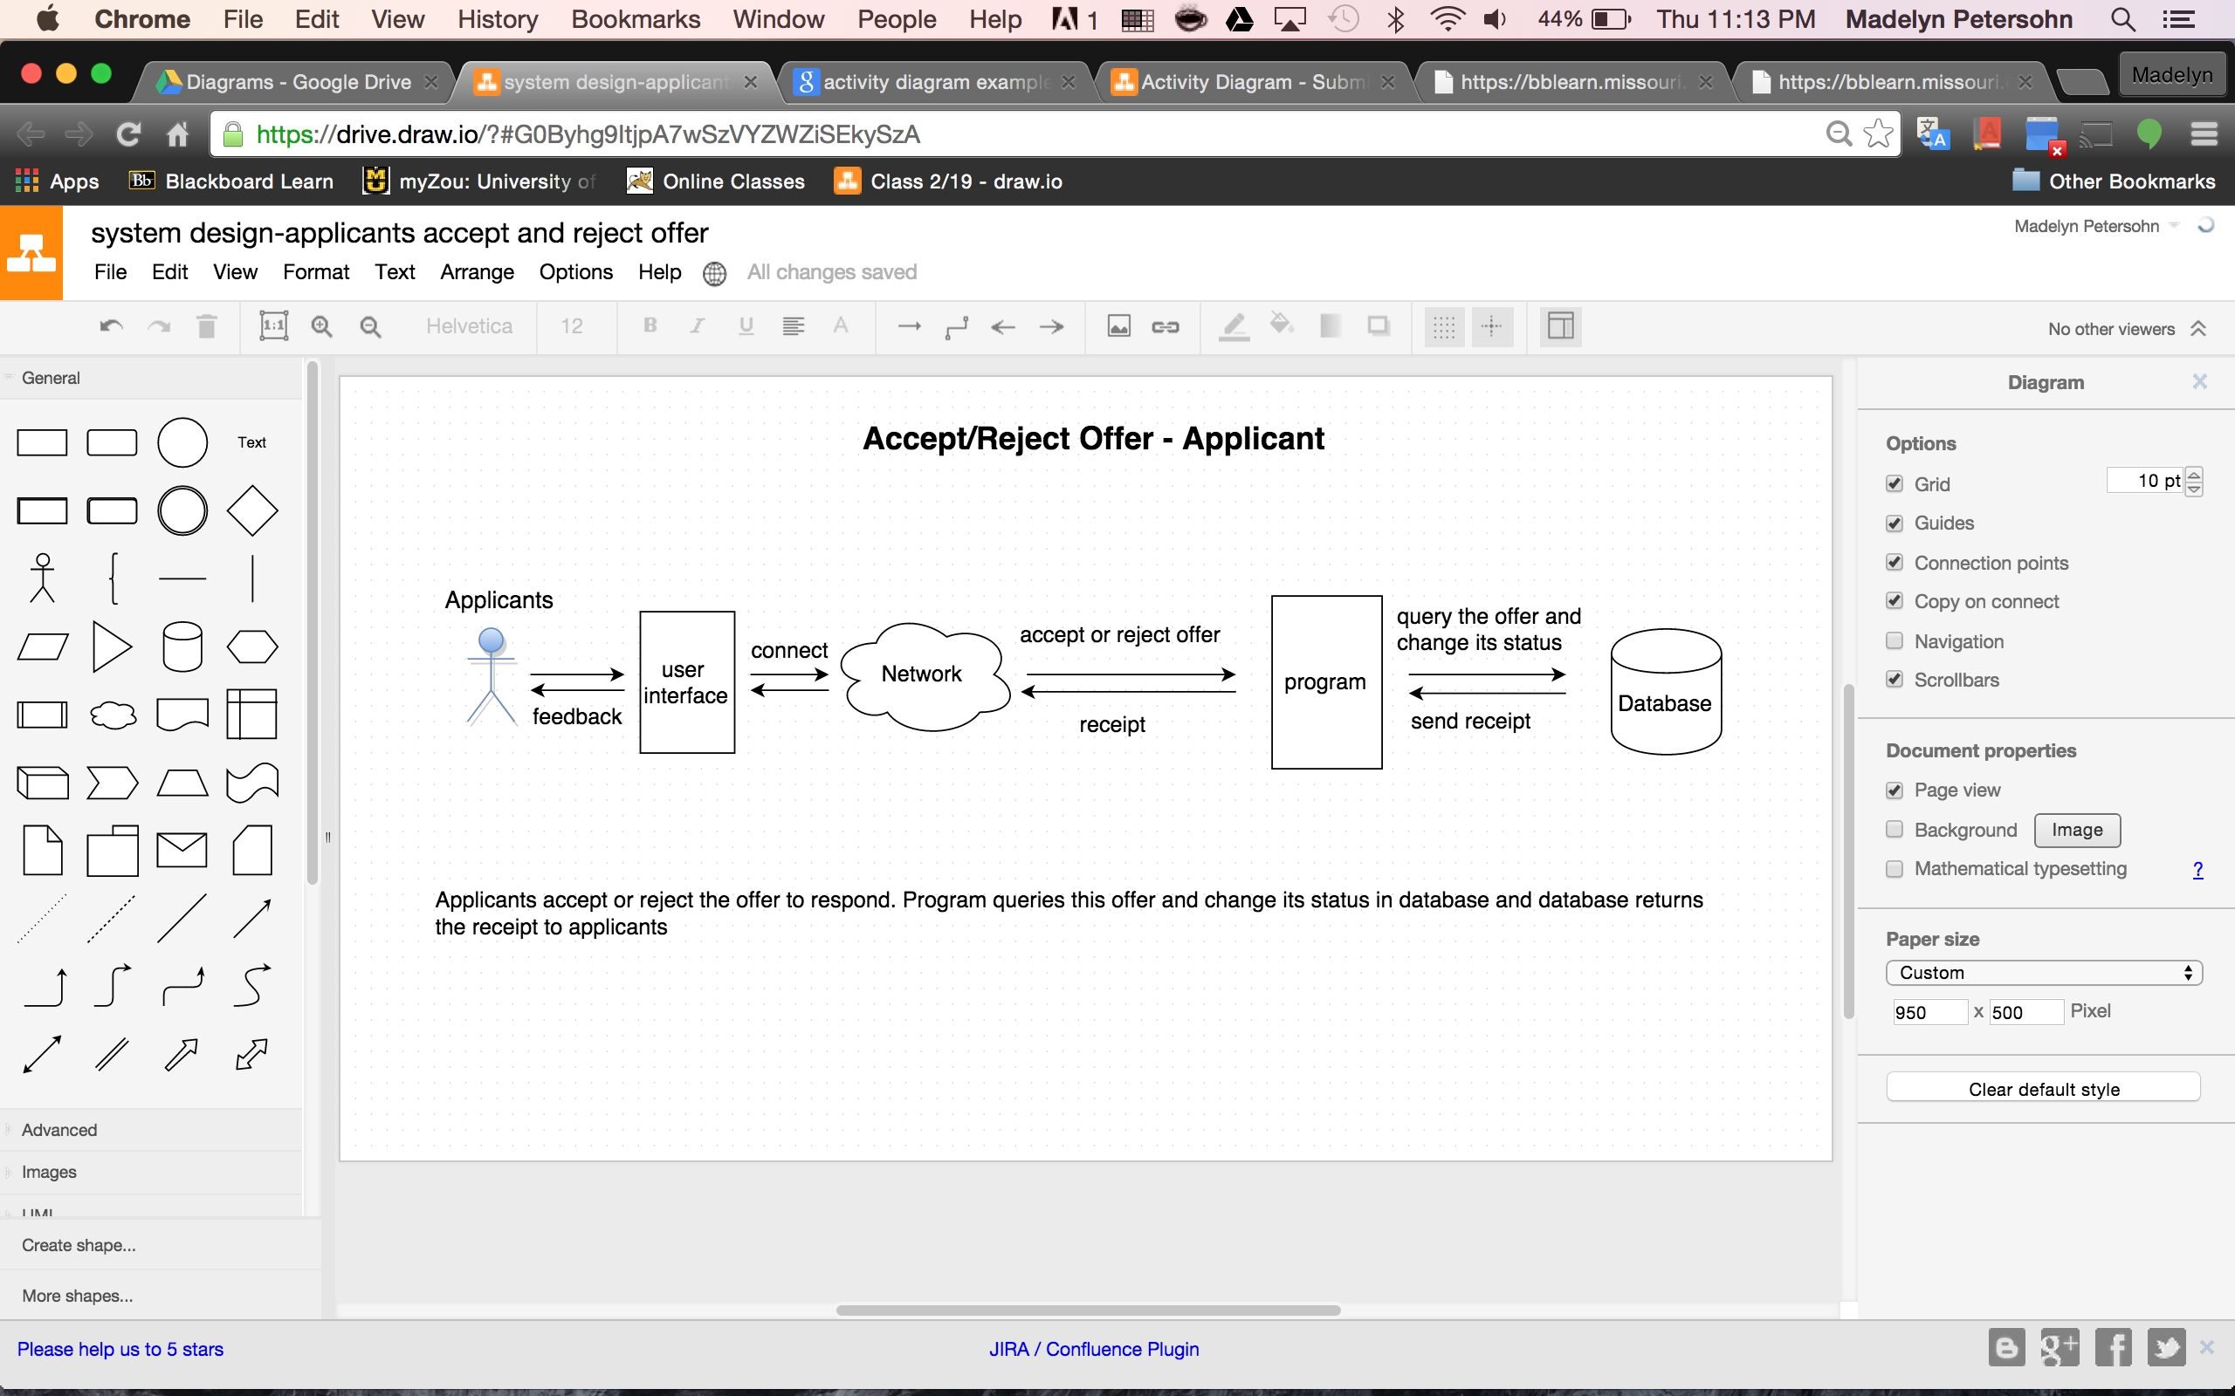

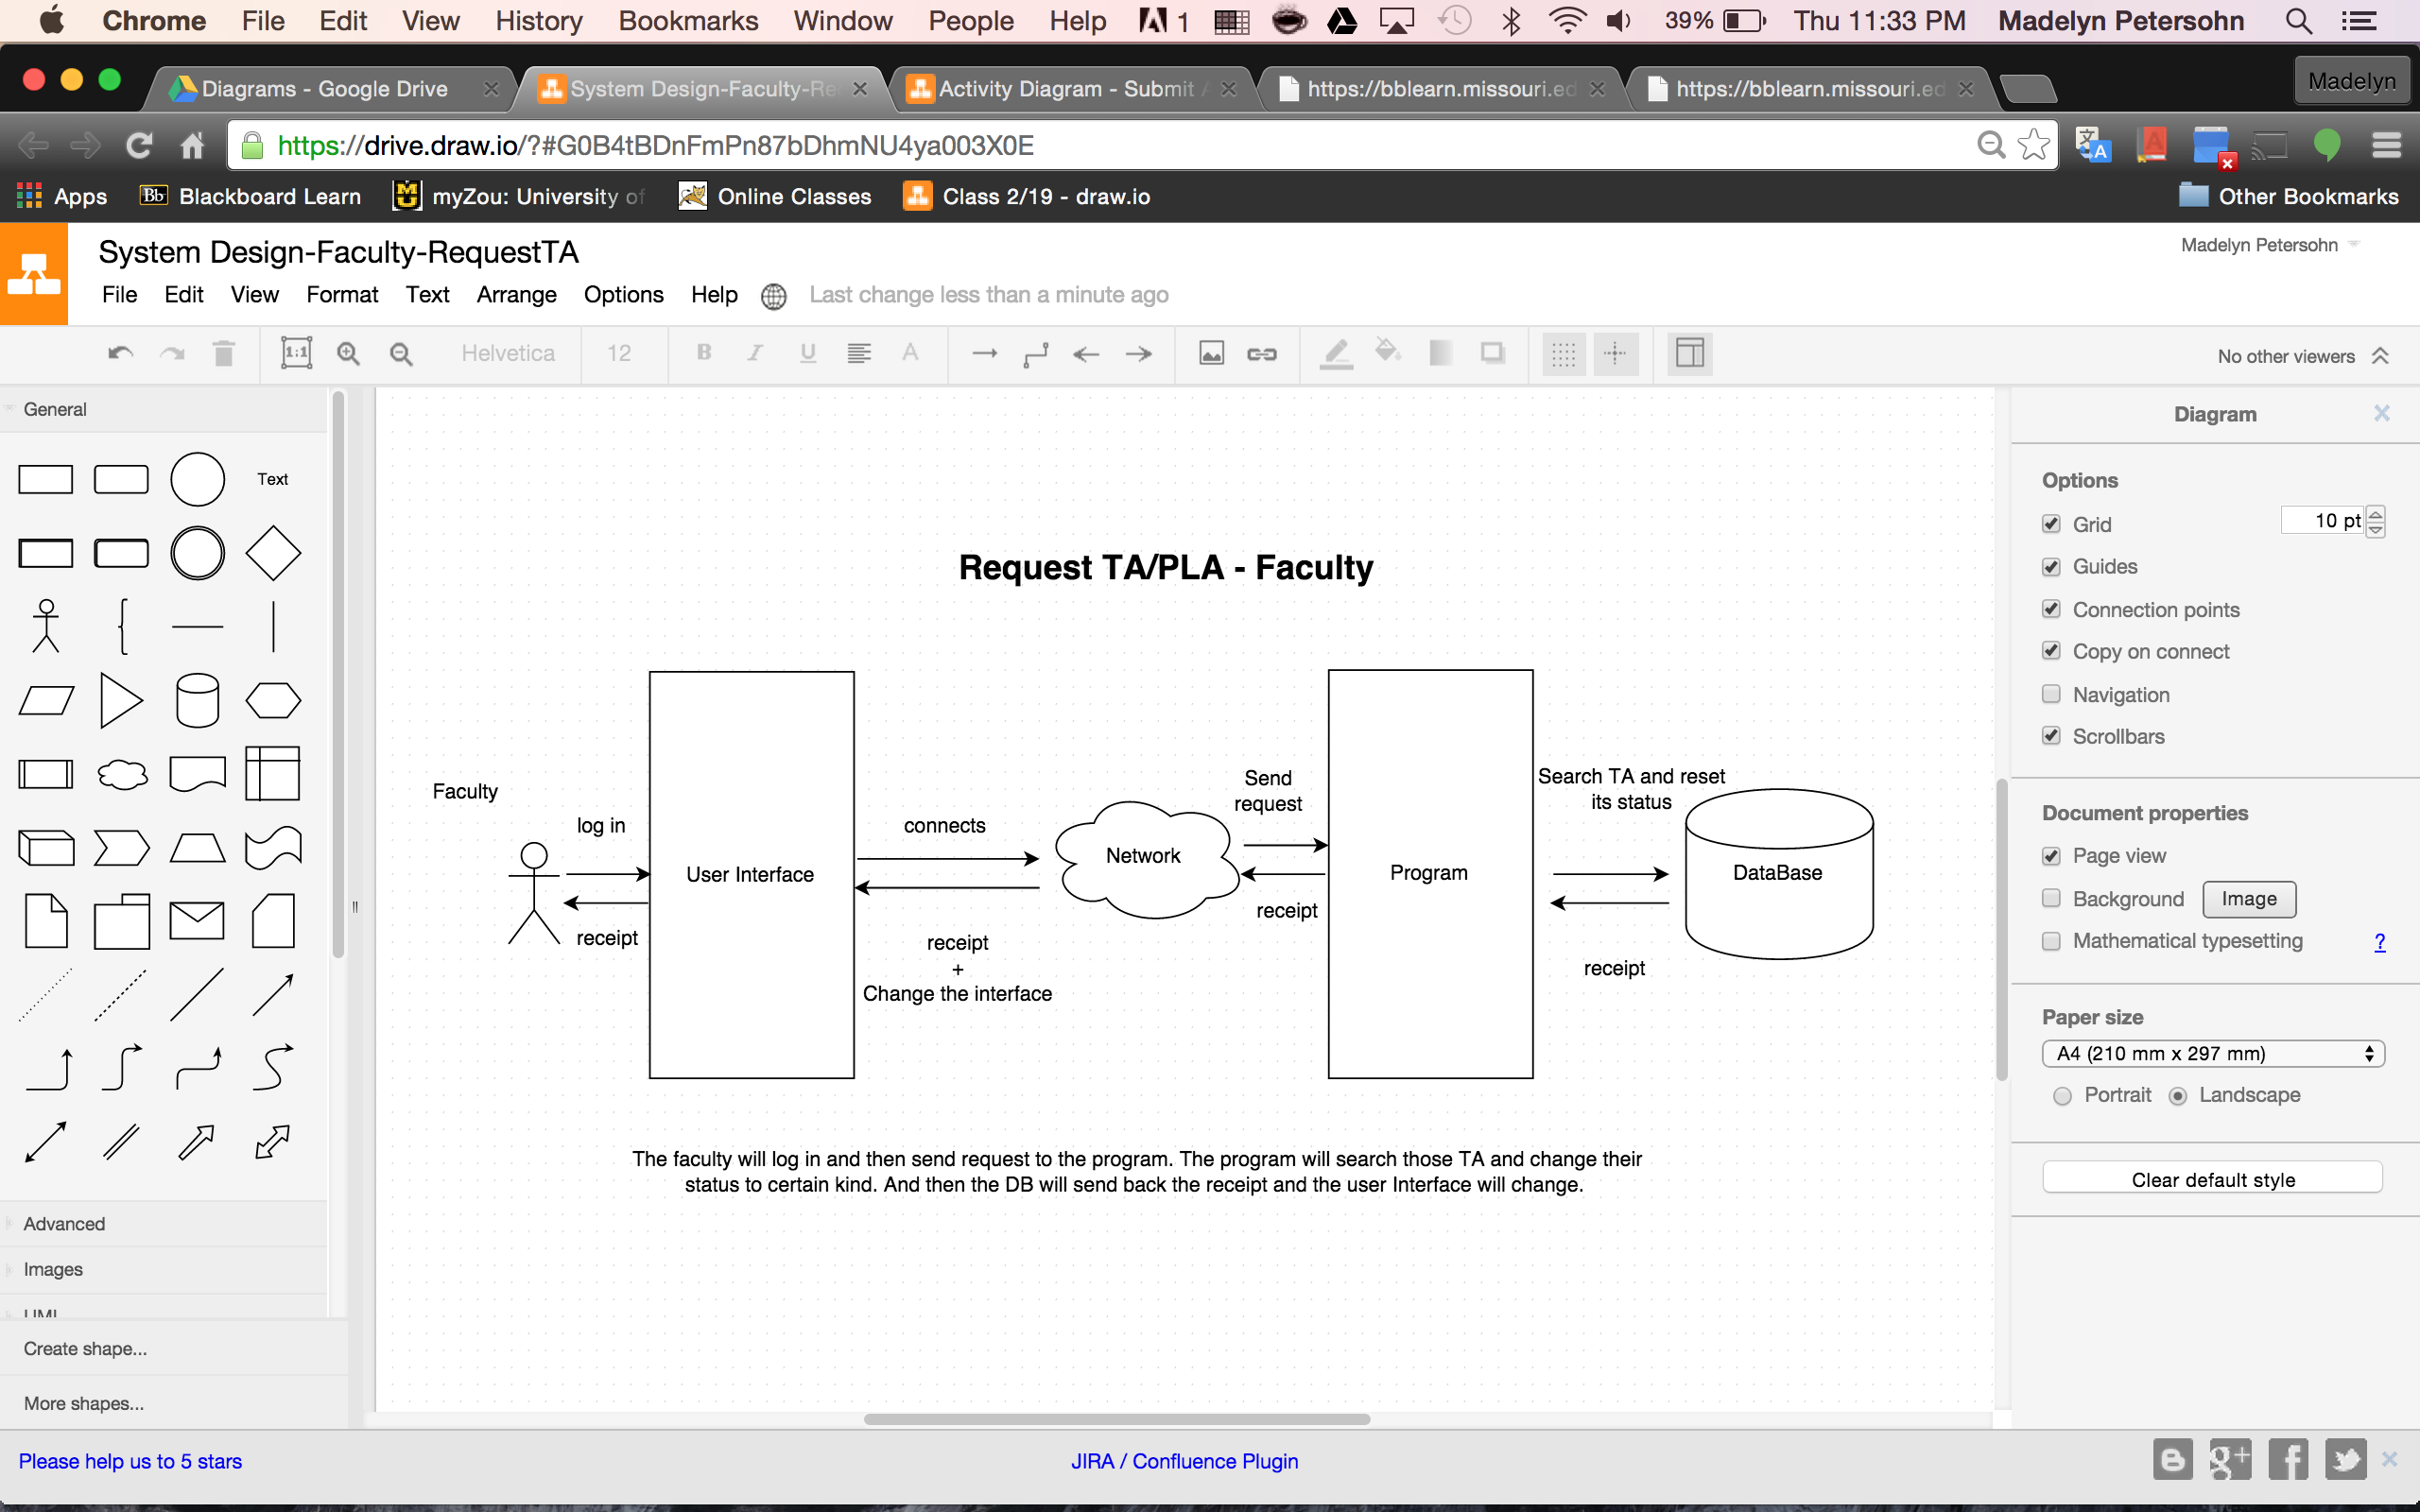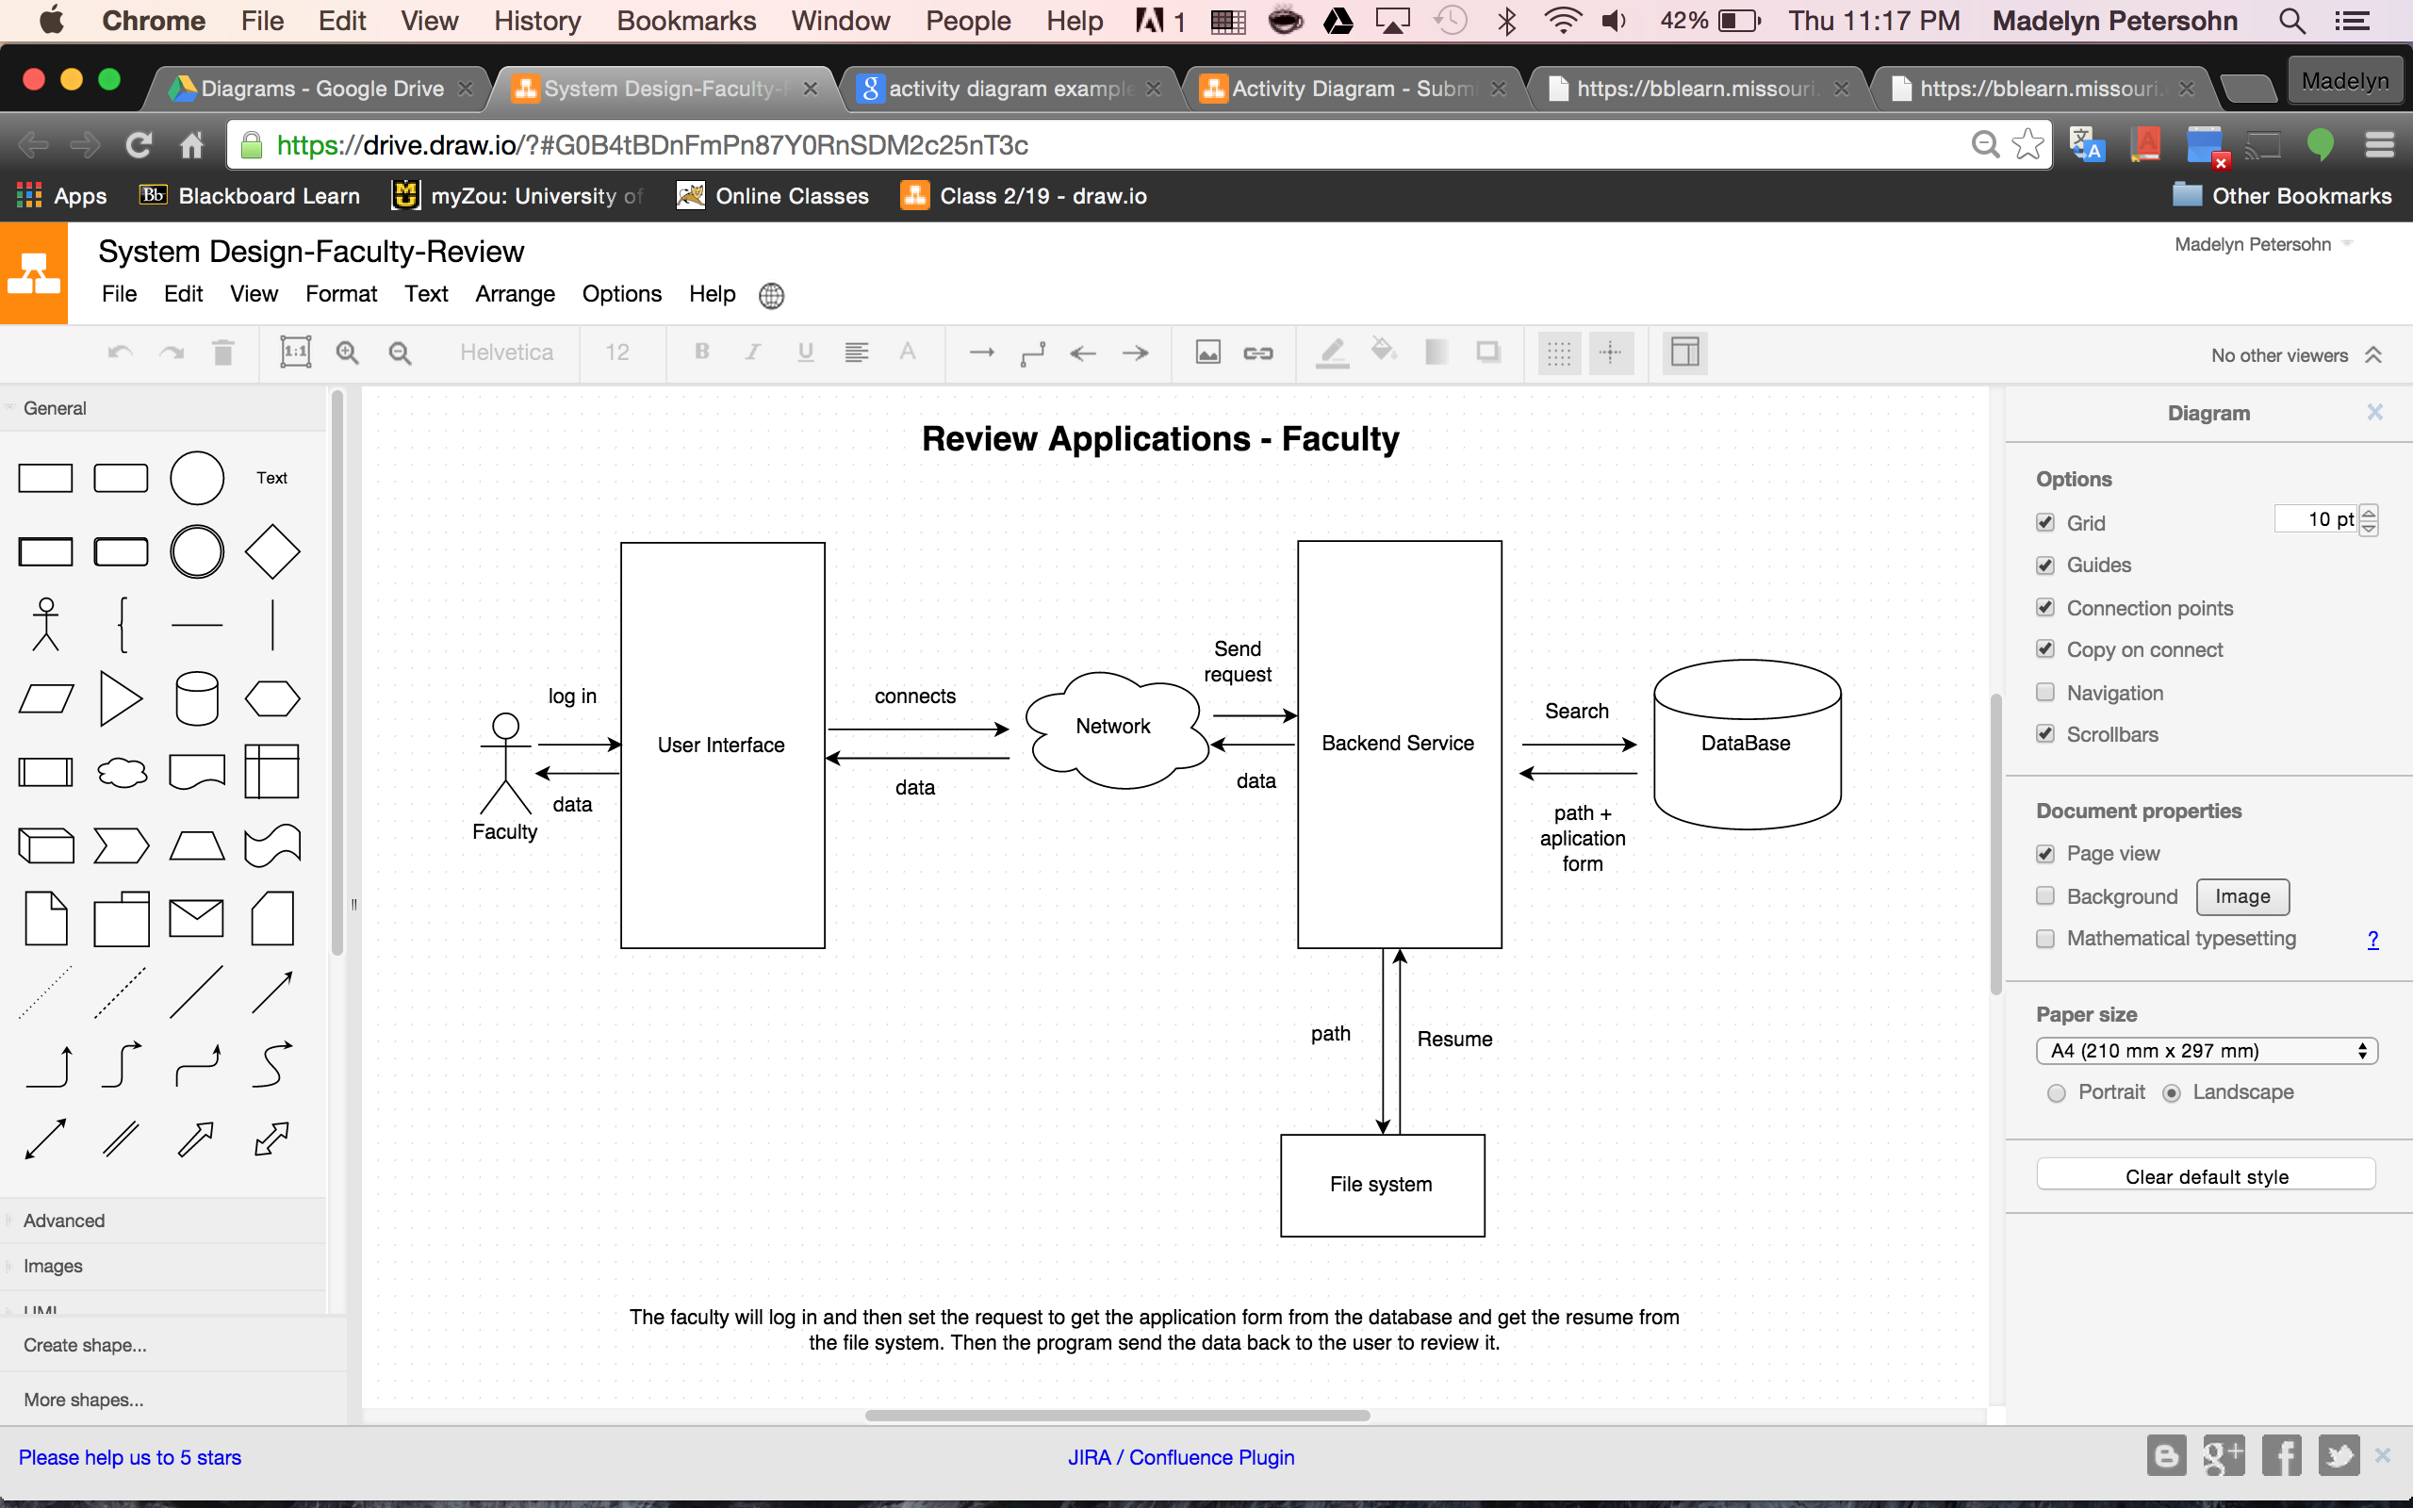

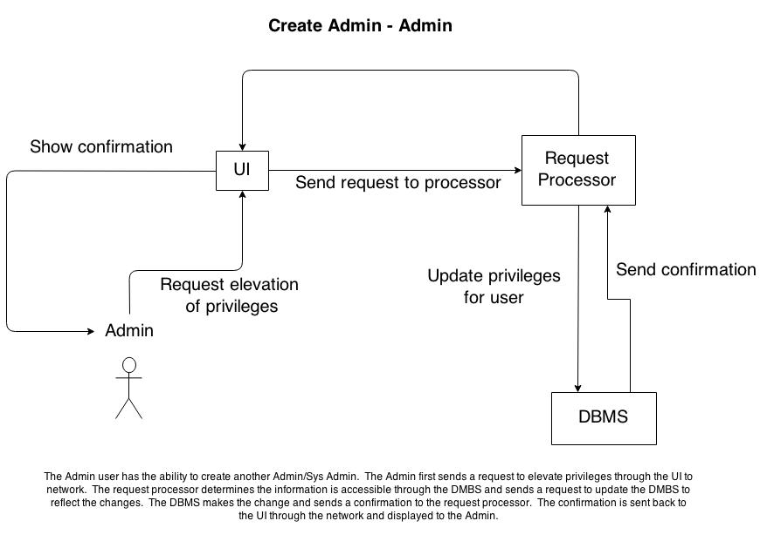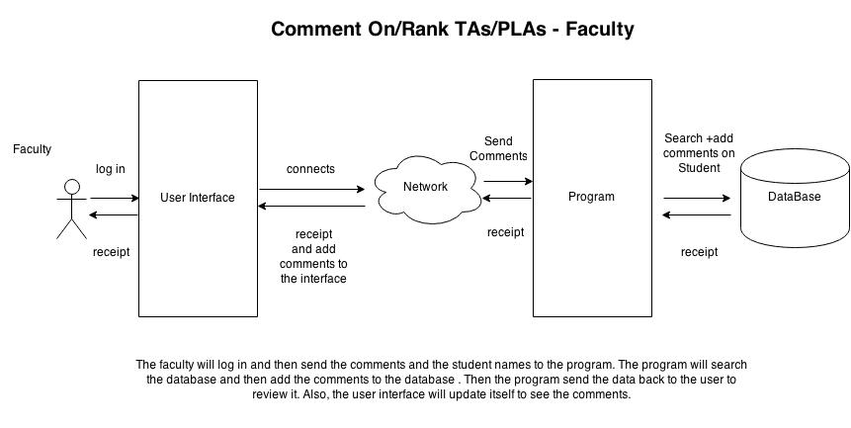

## Activity Diagrams

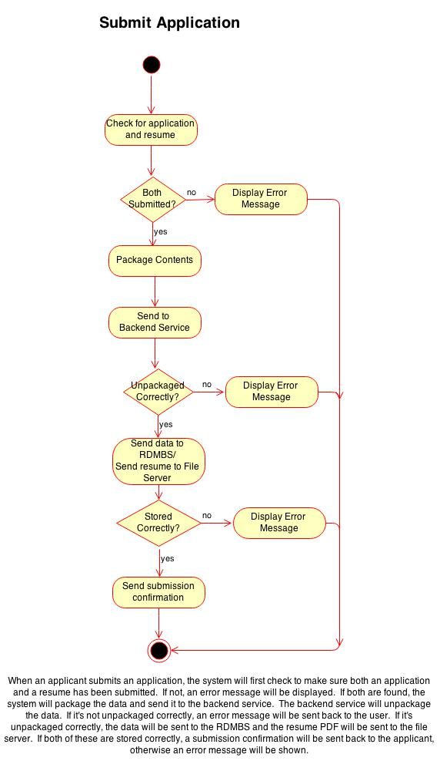

## Macintosh HD:Users:madelynpetersohn:Downloads:Activity Diagram-View.jpg

## Macintosh HD:Users:madelynpetersohn:Downloads:Activity Diagram - Assign applicants to courses.jpgAssign Applicant

## This diagram shows how an applicant will be assigned to a course. First a course is chosen. Next the number of spots is checked to ensure that an applicant is needed. Finally, the applicant needs to meet any requirements before being assigned to the course.

## Sequence Diagrams

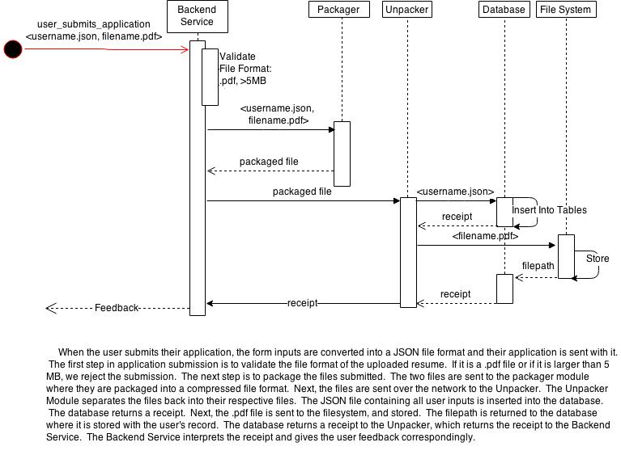

Admin Assign TA/PLA

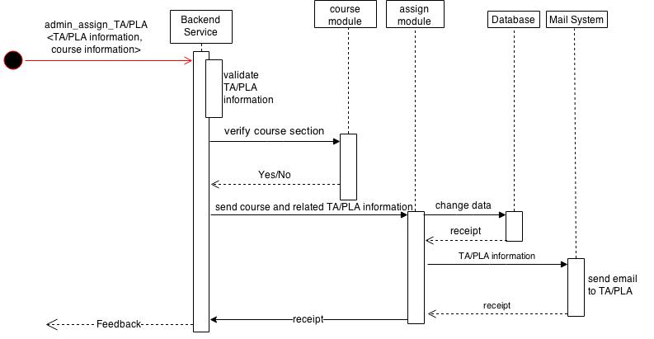

The ad

View Applicant Info

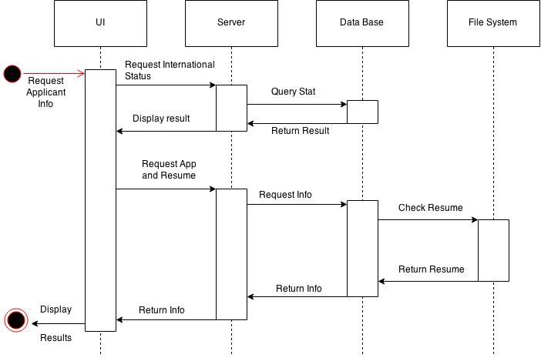

## ERD

